Maths Project – Design and make a box for chocolates.

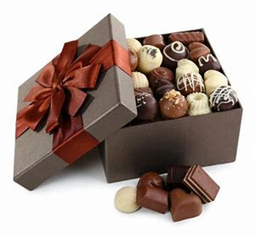

You are setting up your own company to produce boxes of chocolates. You want your product to be unique.
Task 1:
Decide on a name for your chocolates.

Task 2:
Think about what kind of box you want to make for them, and how big the chocolates are likely to be.
Choose something in your house that is about the size and shape of the chocolates that you want to make – a lego brick, a chess piece, anything to help you get a sense of how big. Most chocolates are small and round but yours don’t have to be; one chocolates maker has very long thin chocolates:
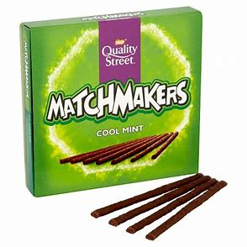

Task 3:
Think about how many chocolates you want to have in your box.
Task 4:
Using paper, design a box for your chocolates. The box needs to be able to shut completely, otherwise the chocolates will fall out. You can use different colours to create an attractive box.

If you want to do a simple rectangular box, then you can copy the design below onto paper or card and make this shape. I encourage you to be creative and make a more complex shape.

When you have made your box, take a photo of it and put it on twitter.
Try to work out the volume inside the box as well, and to really challenge yourself you could work out the surface area (the area of all the sides of the box).

Task 5:
Helen is also a chocolates designer. She is trying to create a tray for chocolates to display in the supermarket. This tray does not have a lid. She wants to use A4 paper.
This is what she tries first:
She measures 1cm in from each corner.
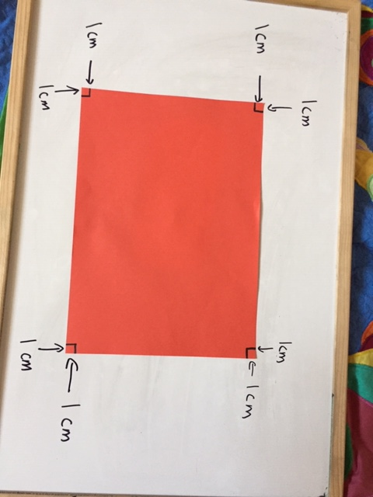
Then she cuts each corner out.
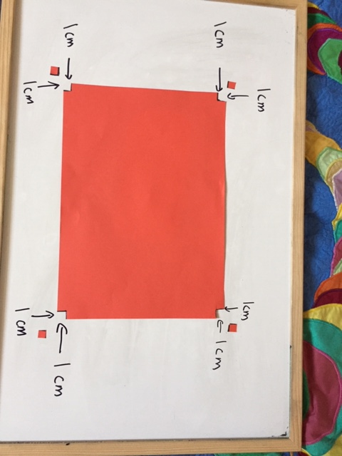

Then she draws on lines to connect each cut out section.
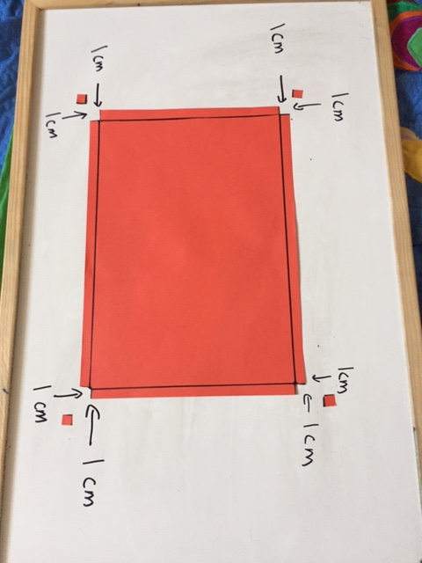
Then she folds the 4 sides up to make a tray.
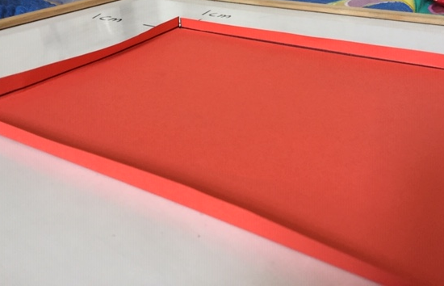

Helen does not think this is a very good tray. She thinks it will not take many chocolates.
She works out it’s volume:
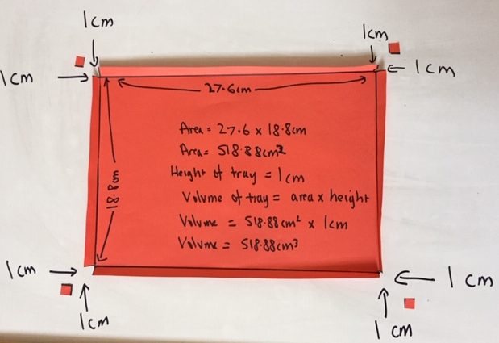

Helen decides that she wants the tray with the biggest volume, so she can get the most chocolates inside it.
She begins to try another tray:
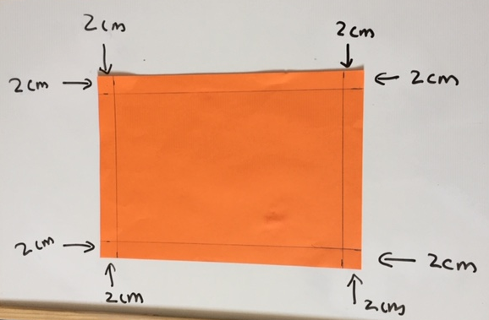
This time, she takes 2cm from each corner.
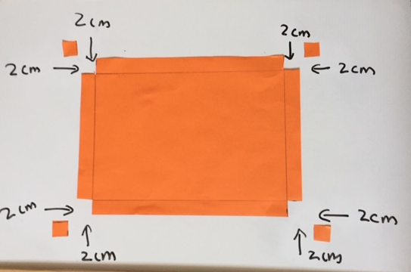

Task 6: finish off the tray that Helen started with 2cm cut out of each corner. Work out the volume of the tray.

Task 7: for this task, you will need to explore. You might use paper to explore initially, but then try to use words and pictures and maths to explain what you have done.
Helen wants a tray with the largest possible volume. How much does she need to cut off each corner?
Keep a journal of what you think and try.
Write down your initial thoughts.
Try cutting a different amt of cm of each corner and working out the volume.
Write down what you notice about the volumes.
See if you can put the cm cut off and the volume in a table, and what you notice when you look at your results.

