What does the ‘FACT’ key on a calculator do? [Worksheet]
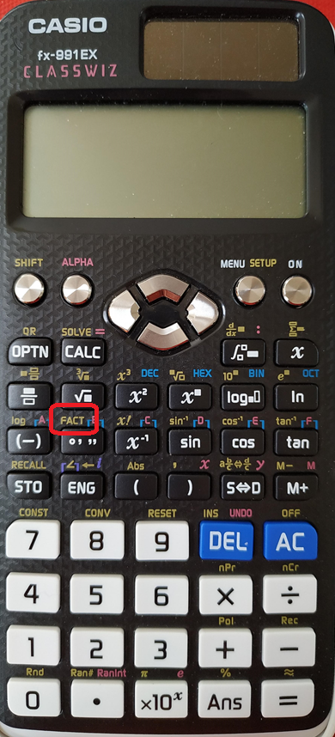
This works with the new Classwiz calculators (of any type) and fx-83, fx-85, etc.

You are going to use the ‘FACT’ command.

This will only work on an ‘answer’. You can enter a calculation and press ‘=’, before then using shift to get ‘FACT’, or you can type a number, press ‘=’ and then do ‘FACT’.

Type in 6, press ‘=’ and then do ‘FACT’. Make sure your display looks like this:

For lots of the rest of this lesson you will need to make a prediction before you use your calculator to find out what actually happens.
Number | Prediction | Calculator
10
9
12
15
22
4
14

Find a number that will give an answer that is three different numbers multiplied together

Which multiples of 4 will have an answer that includes 2² ?
4 = 2² | 16 = | 28 =
8 = | 20 = | 32 =
12 = 2² x 3 | 24 = | 36 =
Which ones include 2² ?

The only numbers that appear in the answers are prime number (the ‘FACT’ function writes the numbers using the product of prime factors).
Try typing a prime number. What happens?

Predict which of these numbers are prime. If you can tell a number definitely isn’t prime, explain how you know. Then (afterwards) try them out.

Number | Prediction: is it prime? (If not, how do you know?) | Calculator
135
134
133
132
131
130
129
128

Can you find some 4-digit prime numbers? Write down a list of 10 plausible numbers to try.
Then check them.
4-digit number | Calculator |  | 4-digit number | Calculator

What do you think the calculator will show if you type in the following numbers and press ‘FACT’?
It is really important to try to think about this before you type it in. It is pointless just typing them in and writing down the answers.

For each question: think about the question, predict what the calculator will say (you might need to write your working/ideas down on paper), and write down your prediction. Then type it into the calculator to check your answer.
Calculation | Prediction | Calculator
77 x 15

Calculation | Prediction | Calculator
6 x 10

Calculation | Prediction | Calculator
100 x 33

Calculation | Prediction | Calculator
10 x 9 x 8 x 7 x 6 x 5 x 4 x 3 x 2 x 1

10 x 9 x 8 x 7 x 6 x 5 x 4 x 3 x 2 x 1 can be typed in more quickly using the key next to the FACT button. 10! means 10 x 9 x 8 x 7 x 6 x 5 x 4 x 3 x 2 x 1.

In a similar way, 4! = 4 x 3 x 2 x 1

Carry on with the important idea of working out what you think will happen and then trying it out by typing them in:
Calculation | Prediction | Calculator
11!

Calculation | Prediction | Calculator
12!

