Vedic Mathematics - ANSWERS
The questions are really prompts for things to explore, so do spend time on them and thinking about their implications, rather than just answering them and checking them against these answers.
The answers here are really only provided in case you get stuck.
Q1 Choose a few numbers and work out their digital sums.
Q2 Is it possible to get every digit as an answer? You cannot get a zero. Earlier on the page it says that this method is only used with positive whole numbers. That means there must be at least one digit that is bigger than 0 and that we are adding on to it. The answer must be positive.
Q3 What is the smallest number for which you have to do the adding process twice before it gives you the digital sum? 19 1 + 9 = 10 1 + 0 = 1
Q4 What is the smallest number for which you have to do the adding process three times before it gives you the digital sum? 199 19 10 1
Q5 What is the biggest number for which you only have to do the adding process once before it gives you the digital sum? 111111111 9
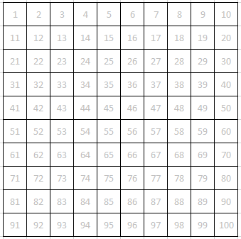
Here is an ordinary hundred-square, with the numbers in grey.
You can see the answers in the Excel file.
Over the top of each number, write its digital sum. Be careful with those that require more than one step to give you a single digit!
What patterns can you see in your answers?
There are diagonal lines of the same number.
‘Vedic mathematics’ is usually carried out on a multiplication square.
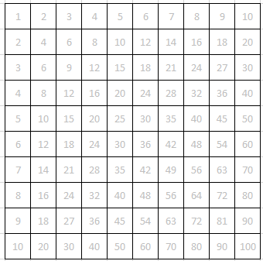
Repeat the process with this multiplication square.
Again – see the Excel file.
How is it different from the hundred-square?
What patterns can you see in the answers this time?
There is some symmetry. Each number appears in a way that has symmetry along the diagonal starting at the top left.
It also has rotational symmetry order 2.

Use the Excel file: “Digital sums”
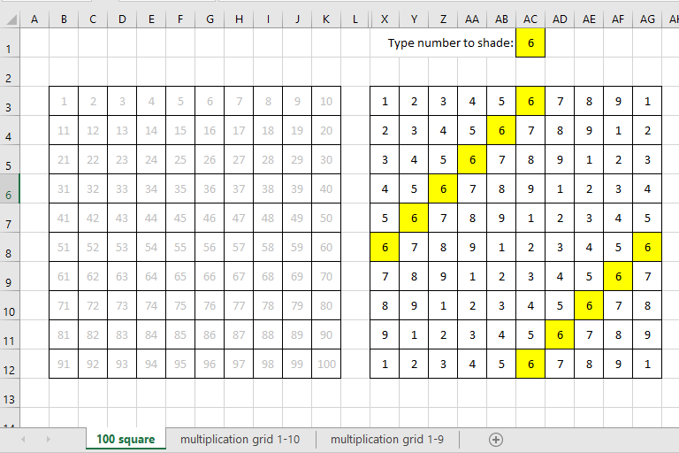
When you type a number in the yellow cell it shades all the appearances of that number in the digital sum table.
What patterns can you see? There are diagonal lines of the same number.
Will these patterns continue if the original numbers continue beyond 100 ? Yes

Now select the sheet ‘Multiplication grid 1-10’
What patterns can you see now? These are harder to spot! Have a go on this sheet before trying on the ‘Multiplication grid 1-9’ sheet.
Why is it easier to see what is going on in this sheet? The section up to 8x8 is the important part. The 9 row and the 9 column all gives answers that are 9. (This is linked to the rule for deciding whether a number is divisible by 9: when you add the digits that answer is divisible by 9.)
Some numbers have the same patterns as each other but are reflected or rotated. Which numbers are related? Use the yellow and pink cells to help you.
1 and 8, 2 and 7, 3 and 6, 4 and 5. They are all pairs that add up to 9.
Vedic circles
I have highlighted the second row in the multiplication grid version of the digital sums
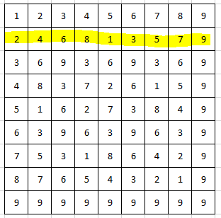
Here is a circle with 9 dots around its circumference:
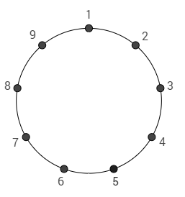
I have used the highlighted row to make this diagram. What have I done?
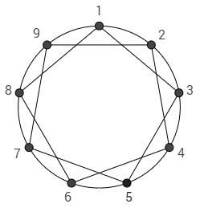

On the circles on the next page, do the same thing for each of the rows.
For Row 1 and Row 8 you get a regular nonagon.
For Row 2 and Row 7 you get a 9-pointed star. (They are the same but you go round the numbers in the opposite direction. This is true for all of the pairs.)
For Row 3 and Row 6 you get an equilateral triangle.
For Row 4 and Row 5 you get a 9-pointed star that is ‘pointier’ than the one you saw for Rows 2 and 7.
For Row 9 … you get a single point!

As a final thing, here is an extended version of the multiplication grid (going across to 36). What is going on here?
What patterns can you see ?

