Vedic Mathematics
To work out the digital sum of a number, you have to start with a positive whole number. Add together the digits in the number. If the answer is a single digit, this is the “digital sum”. If it isn’t a single digit, add the digits in this number together. Repeat this process as many times as you need to, until you end up with a single digit.
For example: to find the digital sum of 347, start with 3 + 4 + 7, which is 14.
This isn’t a single digit, so now we do 1 + 4, which is 5.
The digital sum of 347 is therefore 5.

Here are some questions to try and to think about:
Q1 Choose a few numbers and work out their digital sums.
Q2 Is it possible to get every digit as an answer?
Q3 What is the smallest number for which you have to do the adding process twice before it gives you the digital sum?
Q4 What is the smallest number for which you have to do the adding process three times before it gives you the digital sum?
Q5 What is the biggest number for which you only have to do the adding process once before it gives you the digital sum?
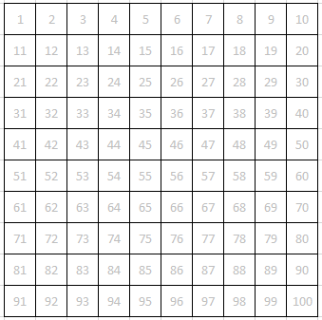
Here is an ordinary hundred-square, with the numbers in grey.
Over the top of each number, write its digital sum. Be careful with those that require more than one step to give you a single digit!
What patterns can you see in your answers?

‘Vedic mathematics’ is usually carried out on a multiplication square.
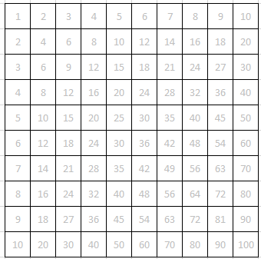
Repeat the process with this multiplication square.
How is it different from the hundred-square?
What patterns can you see in the answers this time?

Use the Excel file: “Digital sums”
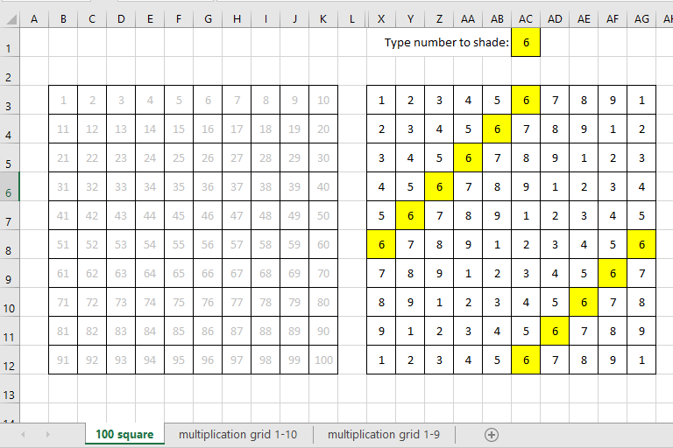
When you type a number in the yellow cell it shades all the appearances of that number in the digital sum table.
What patterns can you see?
Will these patterns continue if the original numbers continue beyond 100 ?

Now select the sheet ‘Multiplication grid 1-10’
What patterns can you see now? These are harder to spot! Have a go on this sheet before trying on the ‘Multiplication grid 1-9’ sheet.
Why is it easier to see what is going on in this sheet?
Some numbers have the same patterns as each other but are reflected or rotated. Which numbers are related? Use the yellow and pink cells to help you.

Vedic circles
I have highlighted the second row in the multiplication grid version of the digital sums
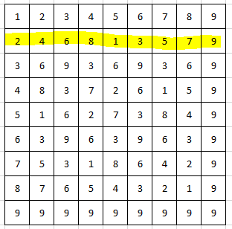
Here is a circle with 9 dots around its circumference:
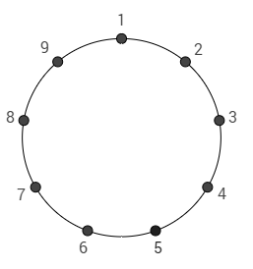
I have used the highlighted row to make this diagram. What have I done?
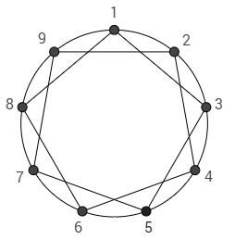

On the circles on the next page, do the same thing for each of the rows.
Row 1
Row 1
Row 1
Row 7
Row 8
Row 9
Row 6
Row 5
Row 4
Row 3
Row 2
Row 1

What patterns can you see ?

