Investigation – Sequences across the world
Q1. The first number in a sequence of numbers is
5
Think of five different rules to continue the sequence, and write down what comes next and what the rule for the sequence is.
For example: 5, 7, 9, the rule is add two.
Think about rules that involve adding, subtracting, multiplying, dividing and combinations of these.

Sequence | Rule
5
5
5
5
5

Q2. In Japan, maths puzzles are very popular. These puzzles are written for Japanese newspapers.
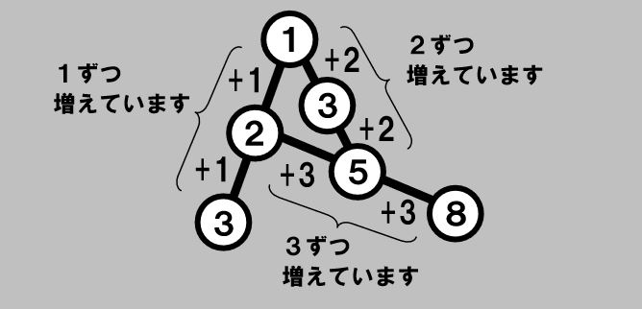
In each line of numbers, they go up the same amount each time.

Try to solve these puzzles:
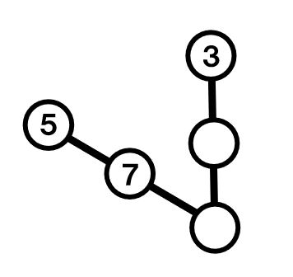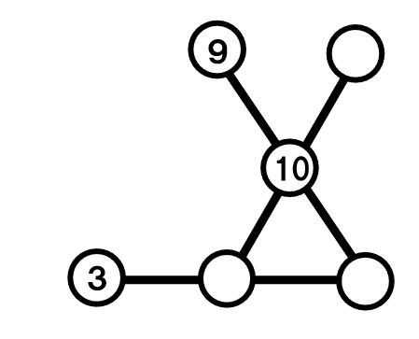
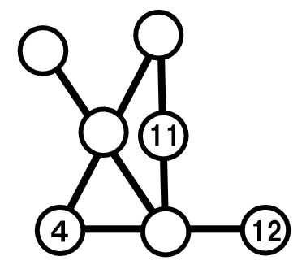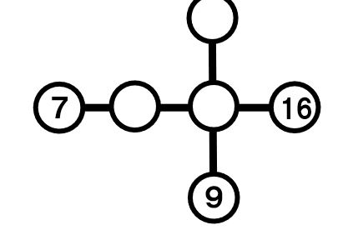

Q3. The third number in a sequence is 13. The sequence goes up by the same amount each time.
What could the sequence be?
Example: The sequence could be 3, 8, 13,18. The sequence starts at 3 and goes up by 5.
Give 5 possibilities for what the sequence could be.
Sequence | Starts at | Goes up in

What do you notice about the number that it starts at and the number it goes up in? It might help to work systematically here – where could the sequence start? What does it have to go up in?
Investigate and explain.

