Thinking about times tables
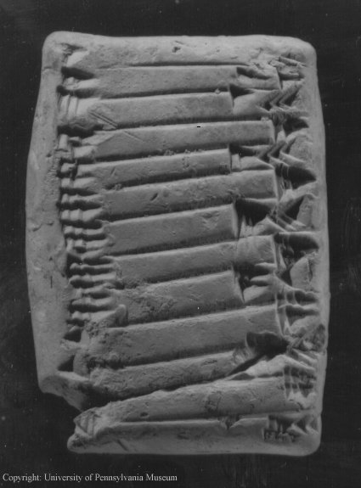
One of the oldest records of mathematics is a Babylonian times table grid.

Q1. Henry is writing out his 2 times table. He writes down
2, 4. What comes next?

Q2. The clay tablet shows the 30 times table. Write out the first six multiples of 30.
Q3. Each of these lists are lists of multiples of a whole number. They don’t necessarily start with “1 times” the number. They are in order, though.
Some of the digits have been replaced by stars. Fill in the gaps!
… …… …
18 345 1*5
** *** ***
30 351 ***
** *** ***
42 357 38*
** ***
Q4. We have received a radio transmission from outer space – aliens have contacted our civilisation.
When it is decoded, we can see the following format. The people responsible for decoding it think that it is a times table. Each letter stands for a different digit. Can you work out which times table it is? Explain how you know. (Here, MH is a two digit number, where the first digit is encoded by the letter ‘M’ and the second digit is encoded by the letter ‘H’.)
R x D = MH
M x D = D
C x D = AR
D x D = HF
A x D = EH
H x D = FD
E x D = FK
F x D = JR
J x D = RF
Q5. The next transmission is even more complicated. Again, each letter stands for a different digit, and they are not the same as the previous transmission. Try to decode this times table. Once you have decoded it try to explain each step.

Q6. GCHQ have now automated the process of decoding the transmissions from the alien civilisation. The next transmission is a table like this:
??????? | **********
9  102  45 | 7  247  73

What words could replace the ???????

What words could replace the ********
Explain how you know.

(Further times tables problems including Q5 can be found in Decoding Mathematics, published by the Association of Teachers of Mathematics https://www.atm.org.uk/ )

