Area Puzzles using rearrangement
At first sight these puzzles look like they will require a lot of work. But if you can spot a crafty way to rearrange the pieces, you shouldn’t need to do more than calculate the area of a square, circle or parallelogram - so in theory, KS3 pupils have all the tools they need to solve them.

I have tried the Orange segments question with both Year 9 (who didn’t know how to calculate the area of a segment) and Year 11 (who did) and found that Year 9 were more successful - perhaps because the long-winded way wasn’t an option for them!

Your students might benefit from seeing a solution to the first of these before they attempt the others - or you could give them a hint by telling them that rearrangement is a useful strategy (although it’s not the only way!)

Orange segments
Original puzzle: https://twitter.com/Cshearer41/status/1051885019357171713?s=20
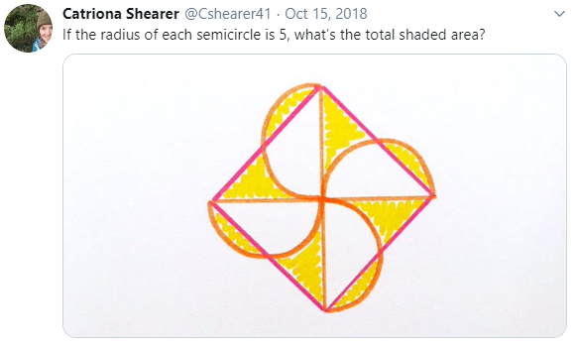
A nice animation that can easily be developed into a full solution: https://twitter.com/ilarrosac/status/1052143770941227009

Spiral
https://twitter.com/Cshearer41/status/1047587722750296064?s=20
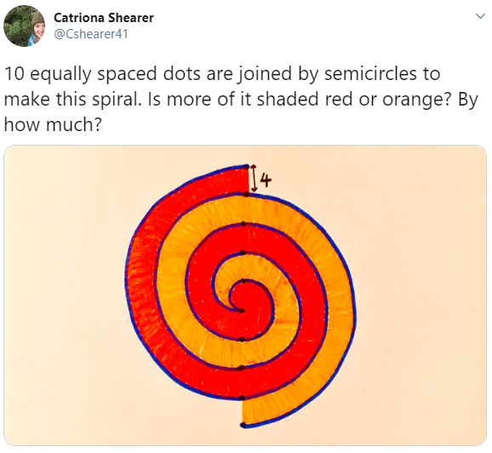
A nice solution: https://twitter.com/ilarrosac/status/1047767031020507136

Stripy hexagon
https://twitter.com/Cshearer41/status/1084479001110958083?s=20
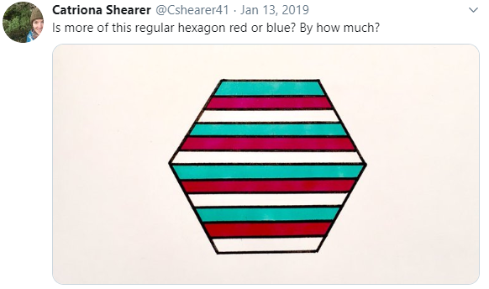
A nice hint: https://twitter.com/nabadvin/status/1084485900787171329

Sunshine
https://twitter.com/Cshearer41/status/1087429545362370561?s=20
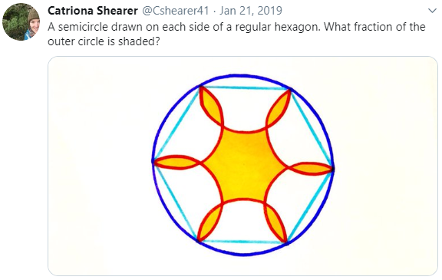
A nice animated hint: https://twitter.com/ilarrosac/status/1087440963730059265
Still requires a little bit of work to get the full solution, possibly using area scale factors.

Stack of squares
https://twitter.com/Cshearer41/status/1216308670931271680?s=20

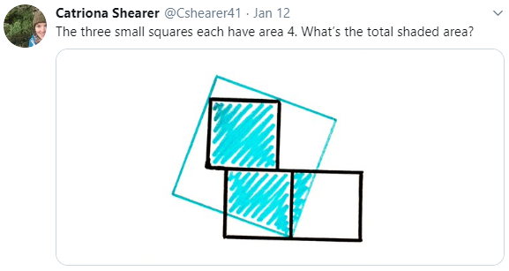
This one is unusual in that there’s not enough information given in the diagram to accurately draw it, so a brute force approach won’t work here unless you’re willing to make some assumptions. However, it does open up some alternative methods of solution, such as this one: https://twitter.com/chzachau/status/1216338160667570177

Or, using rearrangement, you can solve it in the general case: https://twitter.com/edderiofer/status/1216309447070552064

This animation illustrates that it always works: https://twitter.com/PerHenrikChris1/status/1216401118781112322

