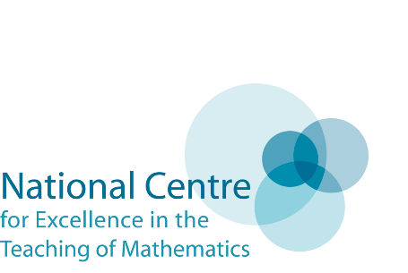

Place – based Assistant Maths Hub Lead
The Cambridge Maths Hub seeks to extend and strengthen its work supporting schools in King’s Lynn and West Norfolk We are therefore now seeking to recruit an Assistant Maths Hub Lead (AMHL) to join our established leadership and management team. The post is for half a day per week from 8 March 2021 – 31 August 2021
The role
The Assistant Maths Hub Lead will work as part of the Maths Hub Leadership and Management Team, normally for the equivalent of half day/week, with a particular focus on their region. The work involves:
- identifying, recruiting, developing and supporting local leaders of maths education to work with the Maths Hub, for example as Work Group Leads or Mastery Specialists
- acting as the public face of the Maths Hub, communicating and promoting our vision and ambition for maths teaching and maths teachers and the results of its work
- identifying leading schools and colleges that demonstrate effective practice and seeking to develop partnership
- developing a strategic understanding of the improvement needs of schools in the area
- supporting recruitment of desired number and type of schools to the Maths Hub activity
- ensuring high quality planning and evaluation of the Maths Hub’s work
The AMHL’s school or college will receive an appropriate secondment rate of funding (10% of FTE including on-costs) from the Maths Hub.
Criteria for applicants (school/person)
The criteria for the schools/colleges providing place-based Assistant Maths Hub leadership are that the school/college should:
- be rated Good, or better, by Ofsted;
- have consistently high levels of pupil performance and progress in mathematics;
- demonstrate strong commitment to teaching for mastery
- demonstrate effective leadership capacity, credibility and commitment;
- demonstrate partnership and networking credibility and capacity, particularly in the target area; and
- be based in the area where the leadership is required.
The criteria for the person fulfilling the Assistant Maths Hub Lead role is that they should:
- be an expert practitioner with deep understanding of what leads to effective mathematics education, including teaching for mastery;
- have significant successful experience as a subject leader for mathematics; and
- be experienced in leading work beyond their own school/college including being skilled at facilitating partnerships and leading collaborative activity.

Assistant Maths Hub Lead application form
Please complete the application form below and e-mail to admin@cambridgemathshub.org by midday on 26th February 2021.
Applicant information
School/college name
School/college URN
Lead contact name
Contact details | Email
 | Telephone number
Name of headteacher/principal
Name of nominated Assistant Maths Hub Lead
TRN of applicant

Maths credibility and capacity
Max 200 words
Maths workforce development:
Provide two or three high impact examples, over the past two years, of support for mathematics teacher development within and/or beyond your own school/college. Include evidence of impact.

Leadership credibility, capacity and commitment
Mathematics leadership expertise:  Provide evidence that the nominated Assistant Maths Hub Lead:  a) is an expert practitioner with deep understanding of what leads to effective mathematics education, including teaching for mastery  b) has significant successful experience as a subject leader for mathematics  c) is experienced in leading work beyond their own school/college including being skilled at facilitating partnerships and leading collaborative activity | (150 words maximum)
School leadership commitment:  Provide a short statement from the headteacher/principal demonstrating commitment and motivation for taking on this system leadership role in mathematics | (150 words maximum)

Partnership and networking credibility
Experience of general collaborative leadership with other school groups and alliances:  Provide evidence of system leadership, wider influencing and collaborative work with schools in your area. Include details of how you have worked with them. | (150 words max)
Experience of specific mathematics partnership building:  Provide examples of effective collaboration with partners including Maths Hubs. Include details of who you worked with and how you have worked with them. | (150 words max)

